Department of History Programmes in 2020-2021

Webinar on Heritage: A Source of Pride and Inspiration in Times of Crisis
Oct 16, 2020
The Department of History organised a webinar on the rrichcraft heritage of India for students and faculty of Shivaji College, to infuse creativity in students during the pandemic which had led to social distancing and isolation. The esteemed speaker Lipika Sud, President of The Guild of Designers and Artists, encouraged the students to learn diverse craft-skills of our country. She also focused on the hardships faced by the artisans and craft-workers in the time of Covid pandemic.

A Virtual Tour of the Silk Routes
February 5, 2021.

A virtual tour of the historic Silk Routes through Zoom platform was conducted by Dr. Sonal for the students and faculty members of
the Department. It aimed at familiarizing the participants with the space and time of the silk routes that connected the West and the East, through long distance trade in myriad commodities as well as to engage with the cultural legacy of the historic routes. The event was inaugurated by the officiating Principal, Prof. Shiv Kumar Sahdev. The online event was attended by 136 students and teachers.

A Webinar in honor of Professor Sunil Kumar on Religion and Societies During the First Millennium CE-An overview
February 19, 2021

Professor B P Sahu from the Department of History, University of Delhi, delivered a lecture on the theme. He acquainted the students with the broad contours of religion and society, during the ancient and early medieval Indian history. The webinar was inaugurated by the Principal, Prof. Shiv Kumar Sahdev . After the inauguration, Prof. Khurshid Khan recollected Prof Sunil Kumar’s memories, as a historian and teacher. The webinar was attended by over 140 participants. The lecture was followed by an interactive session wan enthusiastic participation of the audience.

A Webinar in honour of Prof. D N Jha on Sources and the Historian: Some Early Writings on the Revolt, c.1857-1880s’
February 26, 2021

Professor Amar Farooqui, from the Department of History, University of Delhi, deliberated on the theme, furnishing information on the sources of the revolt and the events that followed. He demonstrated how to use the material, to understand the history of the revolt in a nuanced manner.
The webinar was inaugurated by the Principal, Prof. Shiv Kumar Sahdev. Thereafter, Professor Farooqui shared memories of Professor D N Jha as a historian. The webinar was attended by over 125 participants and was followed by an engaging interactive session.

Virtual But Almost There Tours of Patna Museum, Ellora Temple Complex, Ancient Monuments of Egypt, Pompeii, Petra, Wadi Rum Desert-Jordan
March 05, 2021

Prof. Amarjiva Lochan spoke of the heritage and cultural legacy of the sites and underscored the significance of the Wadi- Rum with its rich caches of copper. The tour concluded with a virtual walk around the pyramids of Giza, Saqqara, the valley of the Dead, the Temples of Luxor, Hapshepsut and Philae and Abu Simbel, the temple of Ramses IInd by Prof. Shama Mitra Chenoy.

Virtual Alumni Meet
March 19, 2021

The programme was inaugurated by the Principal, Prof. Shiv Kumar Sahdev with a welcome address. More than 50 participants attended the event. Mr. Anjani Kumar IFS, currently Ambassador to Mali, Mr. Ajeet Vasant IAS, currently Chief Executive Officer, Zila Panchayat, Rajnandgaon, Chhattisgarh were part of the event. The duo alongwith other alumni working in various fields addressed the gathering. Senior faculty members, Prof. Khurshid Khan, Prof. Amarjiva Lochan and Ms. Nishtha Srivastava interacted with the invitees. The programme concluded with a vote of thanks by Prof. Shama Mitra Chenoy, convener of the event and teacher-in-charge of the department.

Online Competitive events for students
April 8, 2021.
The topic of the Debate was “The Online Education Mode is better than the Traditional System” and witnesses enthusiastic participation of the students.The theme of the Painting was “My heritage and I”, where the students showcased their artistic talent. Young budding poets recited their poetic compositions. The students personified historical figures as part of the Character Play competition.
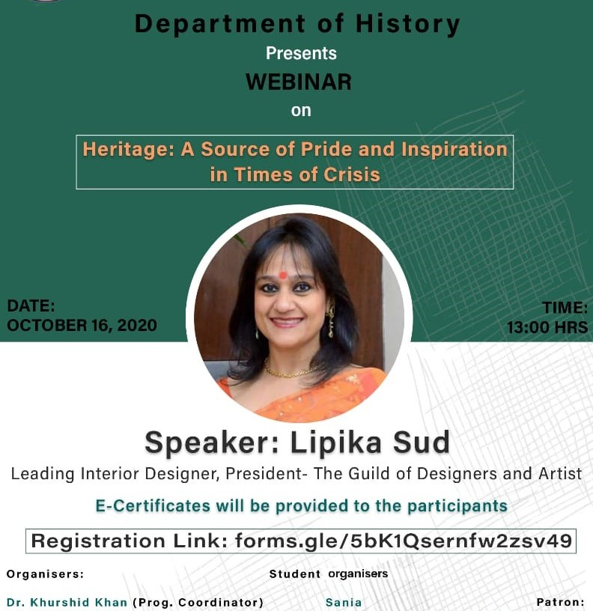

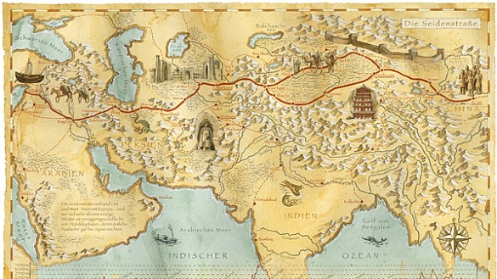

SILKRoutes: A Virtual tour

The Department of History, Shivaji College cordially invites you to a virtual tour of the Silk Route on 5th February 2021 at 2:30 p.m.

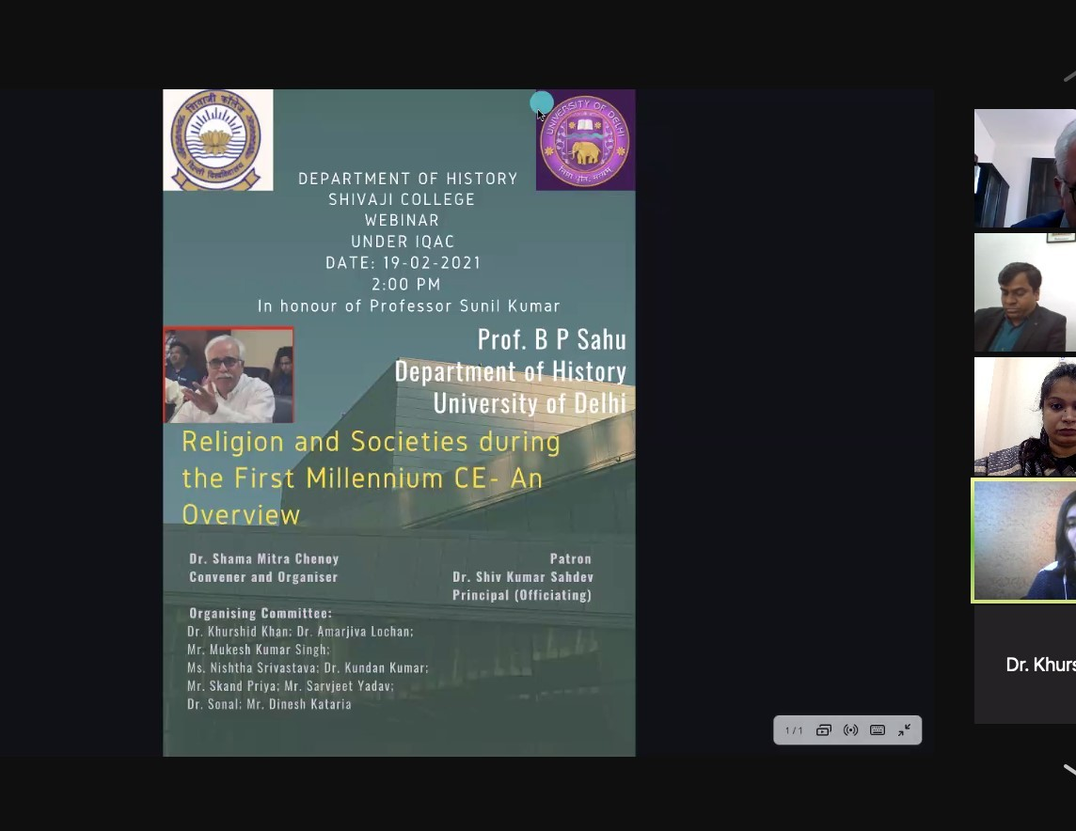

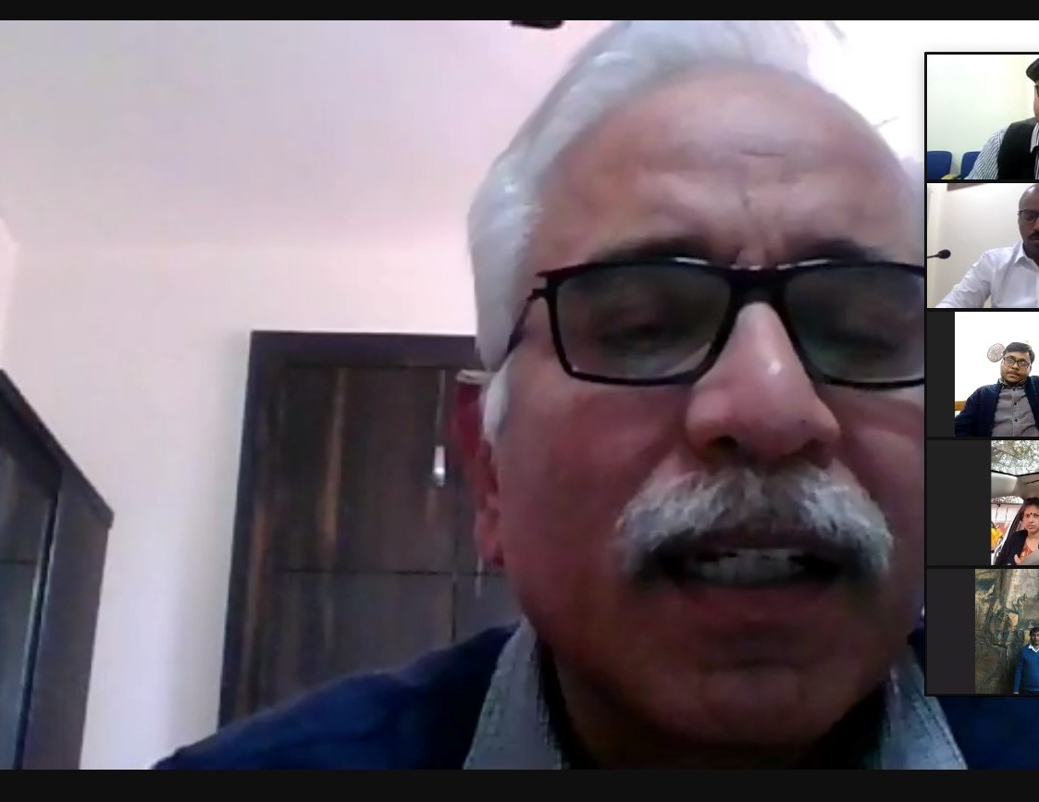

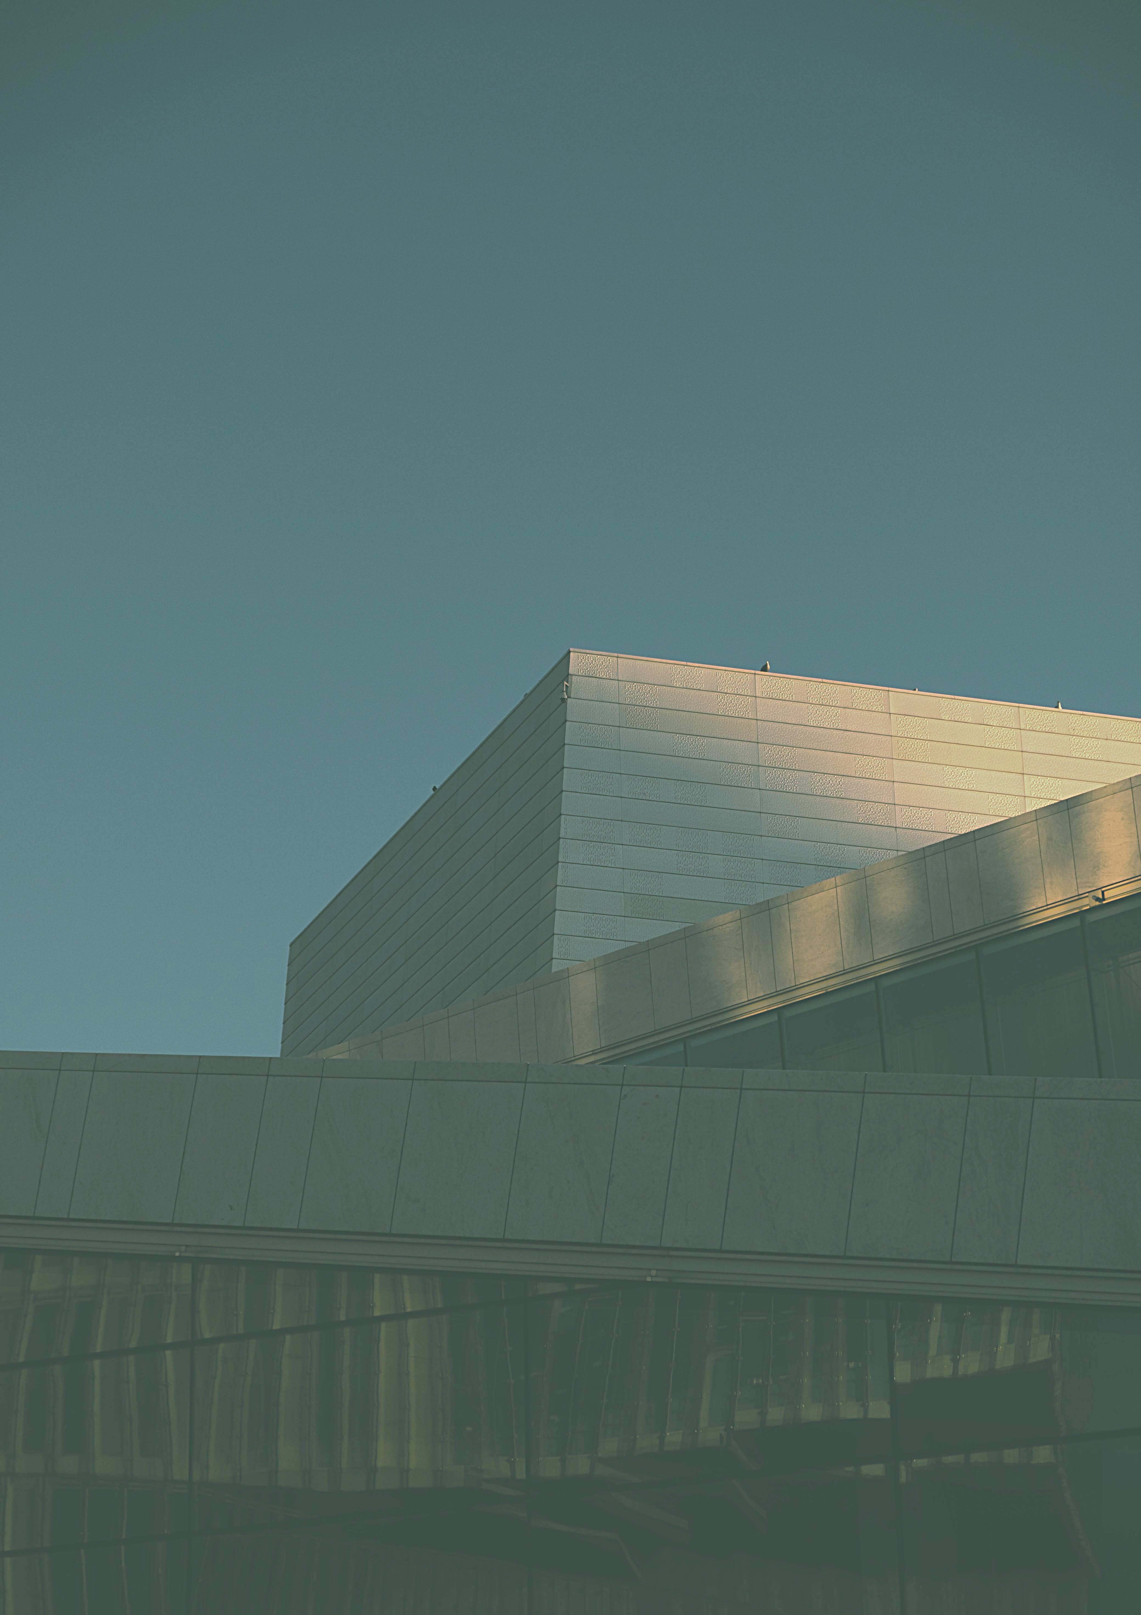
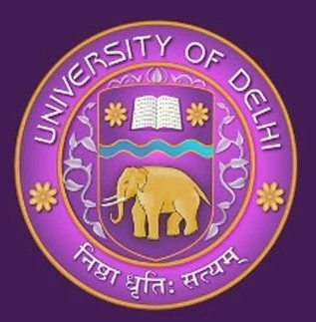
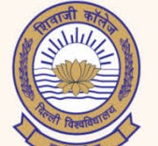
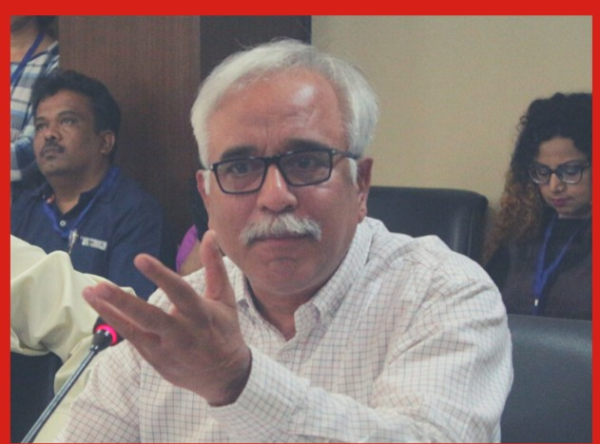

DEPARTMENT OF HISTORY SHIVAJI COLLEGE
WEBINAR
UNDER IQAC
DATE: 19 - 02 - 2021
2 : 00 PM
In honour of Professor Sunil Kumar
Prof. B P Sahu Department of History University of Delhi
Religion and Societies during the First Millennium CE- An Overview

Dr. Shama Mitra Chenoy Patron
Convener and Organiser Dr. Shiv Kumar Sahdev Principal ( Officiating)

Organising Committee:

Dr. Khurshid Khan; Dr. Amarjiva Lochan; Mr. Mukesh Kumar Singh;
Ms. Nishtha Srivastava; Dr. Kundan Kumar; Mr. Skand Priya; Mr. Sarvjeet Yadav;

Dr. Sonal; Mr. Dinesh Kataria

